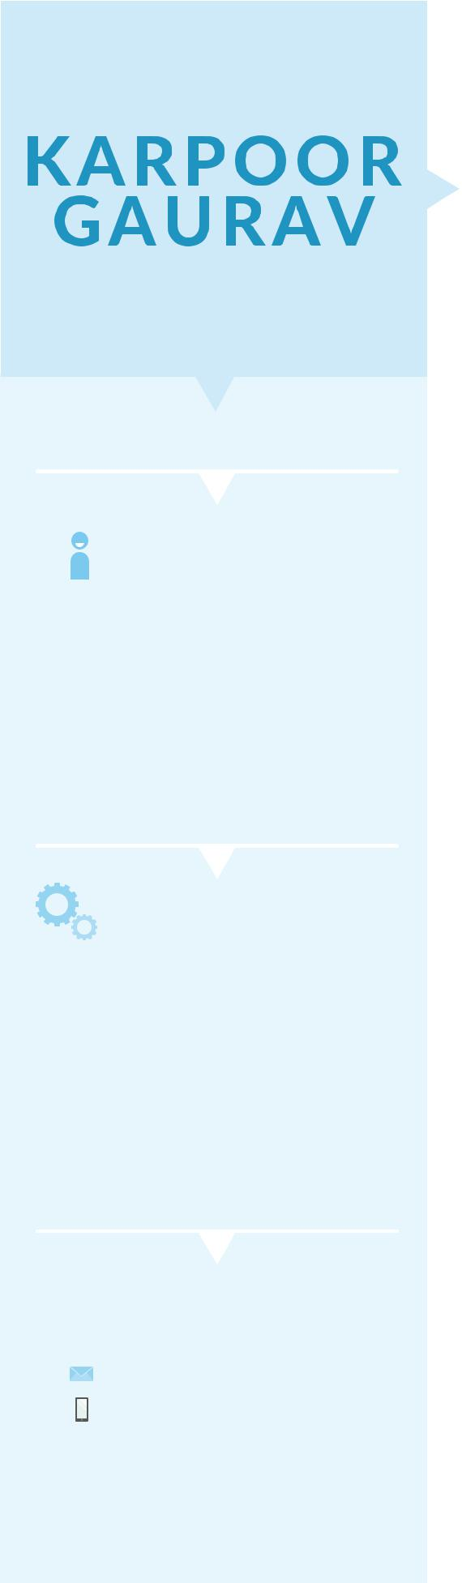

WRITER

ABOUT

An ambitious cinema scope addict seeking to ignite career in script writing and direction that oﬀers increasing responsibilities and the potential for job advancement. I am an engineer by qualification but an artist by heart.

SKILLS

Creative Head

Content Writing

Social Media Enthusiast

Adobe Photoshop Basic

Marketing

Growth Hacking

 CONTACT ME

karpoorgaurav@gmail.com +91-9990721544
OBJECTIVE

I am Dedicated and motivated Engineering Graduate trying my hands in creative writing and looking for a company that oﬀers growth opportunities in creative fields and allows me to utilize my leadership skills and experience.


EXPERIENCE
AARVEE IDEALABS TECHNOLOGIES

August 2015- Present

Working as Creative Writer

Designing creative content for Mobile Application & Website.
Strategies for Campaigns
Handling Social Media of LoudShout, QYKLY and Chiblee. Wrote Ad Films for Mobile Apps.

Growth Hacking & Digital Marketing

FREELANCE WORK
May2014 - June2015

IOTAFLOW SYSTEMS PRIVATE LIMITED
July 2013 - April 2014

Worked as Sales & Application Engineer for 1 years.
Client handling Techniques.
Knowledge of Business Development

 EDUCATION

B. Tech

2009-13

Galgotias College Of Engineering and Technology

INTERMEDIATE

2008

Kendriya Vidyalaya No.1, Armapur, Kanpur

HIGH SCHOOL

2006

Kendriya Vidyalaya No.1, Armapur, Kanpur


ACHIEVEMENTS

Worked as a Vice President of Galgotias Rotaract Club. Head of Kalakriti- Galgotias Dramatics Club.
Won best actor and direction award in Galgotias Dramatics Club. Wrote many stage plays and street plays for Dramatics Club. Wrote Ad Films for Mobile Apps. https://www.youtube.com/watch?v=93qJb0tjNW0 https://www.youtube.com/watch?v=txKSuTiUGFE

